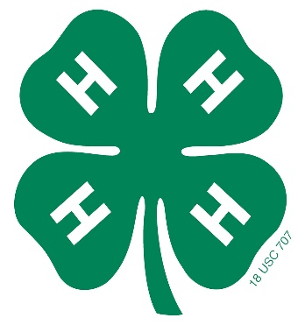
Sandoval County Fair &
This Photo by Unknown Author is licensed under CC BY
Junior Livestock Auction
The Jr. Livestock auction will be held on
Saturday, August 3, 2024, at 1:30 p.m.
We know these are challenging times, but hope that if you are able, you will continue to support 4-H members in their project endeavors.
Add-ons can be made in person on the day of sale or by mailing payment with the form below.
For more information, please visit https://sandovalextension.nmsu.edu/4h/fair.html.
Thank you for being a 4-H supporter!
Add-on Form
Donor’s Name_______________________________________________
Donor’s Address _____________________________________________
Phone Number _____________ Email ___________________________
Exhibitor’s Name | Amount
Total Amount
Make Checks Payable to: Sandoval County 4-H Amigos
Mail to: Sandoval County 4-H Amigos, PO Box 400, Bernalillo, NM 87004

